User brief instruction of release 1

Users can access the Group 42 TNT Media vault by typing <mediavault.wicp.net> in the browser on any device through both internal and external Internet. We Use one developer’s laptop as the server, so if user would like to experience the media vault, please contact me and I will let him start the service on his laptop.

If you have any questions, please do not hesitate to contact me.

My email address is: yzj19920206@qq.com

1. Time chart:

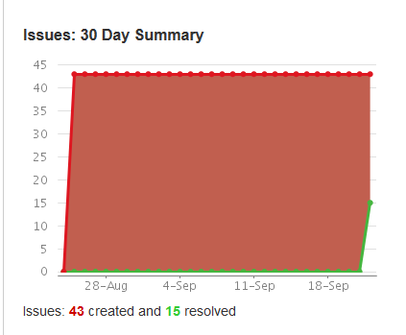

We have created 43 user stories in total, and have finished 14 of them in release 1. 1 is not user story, 8 user stories in spring 1 and 6 user stories in sprint 2.

1. Functions:
2. Register
3. Login
4. Logout
5. Password recovery
6. Verify email address
7. Upload, download, display, delete, and browse PDF, Photo, Music, Video online
8. Search by name, keyword, type
9. Mobile phone UI display
10. Domain name: mediavault.wicp.net
11. External access

Notes:

1. Because of the Internet speed, the uploaded media files will be displayed within 5 min.
2. How to download media files:
3. PDF: click the file, the detail will be shown in a new page, then you can see the download button at the bottom right corner.
4. Photo: click the file, the detail will be shown in a new page, then right click the photo to download
5. Music: right click the “play” button to download
6. Video: right click the “play” button to download